Ashburton Drive Primary School



WA Positive Behaviour
Support

Parent Booklet
2026


ADPS uses WA PBS

WA PBS (Western Australian Positive Behaviour Support) is a program that helps to identify and implement School-wide Positive Behaviour Support: -
* To improve behaviour, teach social skills and foster a positive attitude towards learning
* To achieve higher educational outcomes
* Common language and understanding that is used by all.

HOW IS WA PBS EDUCATIVE?
We teach our students how to behave at school to ensure that they make better choices. PBS views inappropriate behaviour in the same manner that problems in reading or math are viewed…as a skill deficit. When a skill deficit exists, we must teach the appropriate skill.

WHAT DOES WA PBS LOOK LIKE AT ADPS?
W.A. PBS is adapted to the needs of each school and community
Our students learn about our four school behavioural values of: -
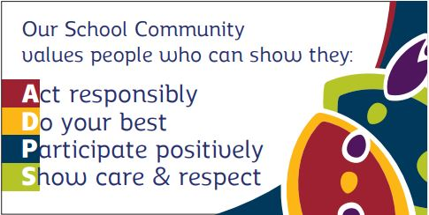

These values underpin various behavioural expectations which have been created specifically for ADPS
How do we know which behaviours to focus on?
ADPS behavioural data is analysed by a team of educators and parents at ADPS on a regular basis from the W.A. PBS committee. Much of this information comes from the pink, and blue slips received by students. This information is used to identify and select the most appropriate lessons from our school behaviour framework. Specific lessons are then scheduled to be explicitly taught for the next term by all classes. This allows ADPS to identify and address particular behavioural concerns at the point of need, as well as identifying overall behaviours that are positively demonstrated.

Lessons are explicitly taught over a period of 2 weeks by each class and are taught in the specific setting to help teach that behaviour. In addition, children are reminded and encouraged by staff at the point of need incidental teaching points. This encompasses both positive reinforcement of those demonstrating the expectation and reteaching/reminding for those who require further support. Systematic teaching of the pro-social behaviours is a routine part of the school day using the same methods as teaching academic skills, through modelling, practice and feedback.

Teachers have the discretion to teach additional behavioural lessons as required by their classes.

How are children encouraged to follow the school values?
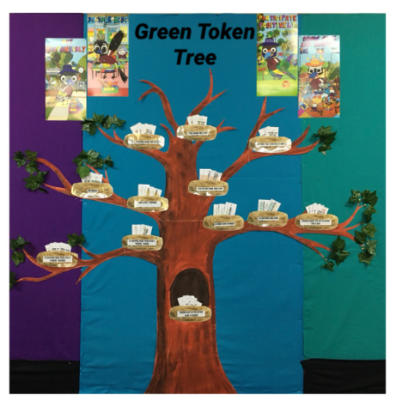
- Positive verbal re-enforcement by all educators in particular, pro-active focus of the expectation of the fortnight
- Students verbally encourage and remind each other of the expectations
- Puppet performances of some behavioural expectations – started in 2018
- Staff lead by example at all times e.g. wearing a hat on duty
- Attendance rewards
- Merit certificates
- At assemblies, audience score points to receive additional playtime
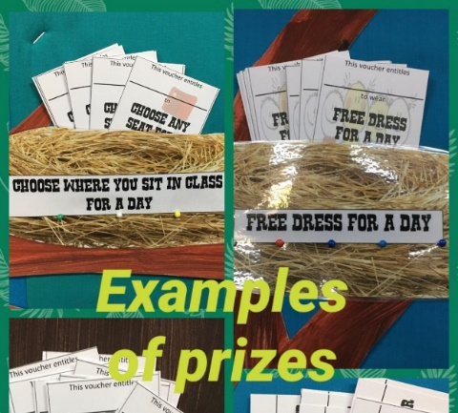
- Daily prize draw – Green Token Tree - linked to green tokens in Ashburtoken system
- Class Dojo points as a tool for encouraging positive behaviours
  - 10 Class Dojo points equates to 1 green Ashburtoken
- Ashburtoken system – see below

Positive Acknowledgement Program
At ADPS we use “Class Dojo” to constantly reinforce positive behaviours. For every 10 Dojo points students receive an Ashburtoken. Specialist staff are linked to classes and relief staff can hand out “Dojo tokens” which will be added to the points tally by the class teacher at a later time. Dojo tokens can also be given to students at lunch and recess breaks to be handed to their class teacher for processing.
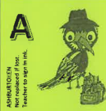
Student achieves 1 GREEN token

3
5
4
1
2

When 5 GREEN tokens have been achieved they are placed in a container in the office, then they come to the office for an entry in the “Green Token Tree” daily prize draw and are exchanged for
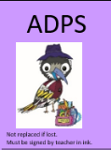
1 PURPLE token

5
3
4
1
2

When 5 PURPLE tokens have been achieved, they are taken to the office for processing. Plus students receive a
TRY-ATHLON Certificate at assembly.
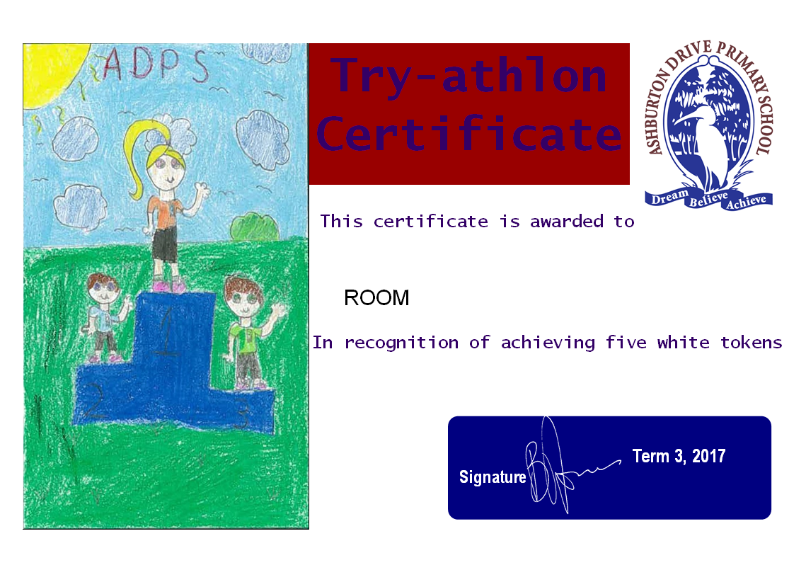

5
1
2
3
4


When 5 TRY-ATHLON certificates have been achieved, students receive a MEDALLION.
5 x TRY-ATHLON certificates = Bronze Medallion
10 x TRY-ATHLON certificates (total) = Silver Medallion
15 x TRY-ATHLON certificates (total) = Gold Medallion
20 x TRY-ATHLON certificates (total) = Platinum Medallion
25 x TRY-ATHLON certificates (total) = Plaque
Try-athalon certificates are recorded at school and sent home.

Try-athalon certificates are recorded at school but sent home.

Personal Best
Personal Best is a great way to say …
“You are doing great at school. Let’s celebrate your good values and behaviour!”
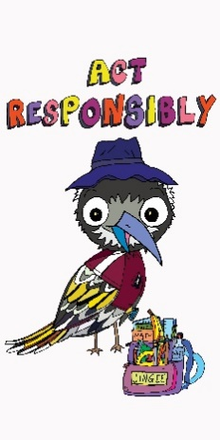
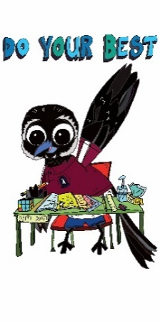
Our school community values people who can show that they...
Act Responsibly
Do their best
Participate Positively
Show care and respect

What is ‘Personal Best’?

Personal Best is a school wide reward system for those students who:
- have shown good behaviour.
- have demonstrated the school values.
- a way to provide feedback on how your child is developing in the areas of school expectations as well as personal and social development.

What happens if my child is in the ‘Personal Best’?

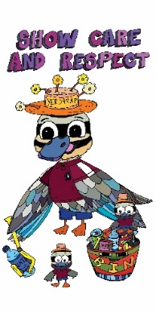

If your child is eligible for Personal Best your child is entitled to participate in an activity just for the Personal Best members. While we keep costs to a minimum, you may be required to pay some costs associated with the reward activities.

How does my child get into ‘Personal Best’?

The guidelines are:

1. All students complete a nomination, Personal Best form. Students self-reflect by giving themselves a score against each criteria.
2. Classroom teachers score students against each criteria.
3. If the teacher’s score is at or above the required level administration will check that students have:
- less than three incidents resulting in detention.
- no withdrawals or suspensions

4. Students who are confirmed as demonstrating our values, as above, will be notified via a letter for parents.

How frequently does Personal Best occur and what are typical rewards?
- Next rewards will be advertised on our display boards around the school.
- Dates will be on the termly calendar.
- Personal Best (P.B.) rewards occur at the end of each term. This is based on the student’s behaviour over the term (usually 10 weeks.) Kindy has a separate P.B. reward to the rest of the school but follows the same policy. These will be held for all Kindy students on a day they would be scheduled to be at school.
- There may be a small monetary contribution required from those who get into P.B.

Examples of previous rewards
- Messy play day
- Movies and popcorn

What will my child do if they don’t get into Personal Best this time?
- Those students who don’t achieve P.B. will reflect on their behaviours. This will help them identify specific areas to improve. They are supported with identifying alternative strategies to help achieve behavioural expectations. This is a valuable learning opportunity for children.

Why shouldn’t I just keep my child off school if they miss out on Personal Best?

- Children don’t learn consequences or take ownership for their behaviour.
- They miss the opportunity to reflect on how they can manage their behaviour more appropriately. This can assist them in making better choices and subsequently, if addressed, can enhance their chances of getting into the next P.B reward. All students use reflection sheets appropriate to their age.
- Each child is supported in identifying key areas that they can address. Not all negative behaviours will necessarily be addressed in one reflection session. This gives children the opportunity to learn how to adapt their behaviour to those that are more acceptable to the school’s values.

How are unproductive behaviours addressed in school?
- Verbal reminders with students linked to expectations. Unproductive behaviour requires feedback and is viewed as a teaching opportunity – a chance to clarify and re-teach expectations. The same calm, instructional approach used when students make academic errors is used to correct behavioural errors.
- Ready To Learn chart – this is a visual reminder to students’ if their behaviour continues to be inappropriate.


Ready To Learn Chart

How does the Ready To Learn chart work at ADPS?

- All students start the day with their names on Ready To Learn
- If students make a poor choice (minor) then they get moved onto the first yellow rectangle (lightest)
- Any further poor choices and they are moved through the chart as such
  - Yellow line
  - Orange line
  - Red line
- If they reach the darkest yellow square they receive time out in their own class in a designated area
- If they reach the darkest orange colour they receive buddy class time out. This is usually in another class in their block and for an appropriate amount of time for the student to have the opportunity to reset
- If they reach the darkest red colour then they are sent to Administration with a pink slip fully completed.

Points to note:
- When children make good choices they are moved back up the chart
- The chart is reset at the end of the day
- Timeout is in a designated area of the class
- If a more serious behaviour occurs e.g. physical incidents, then staff progress immediately to completing a pink slip which is an Administration referral
- If a student is on the “Ready to Learn” section at the end of the day they receive 2 Dojo points.
- If students can correct their behaviour before they receive a timeout, they can be moved back to a lighter square or off the chart
- When relief is present, the timeout in class is removed, and student receive buddy class timeout after they reach 3

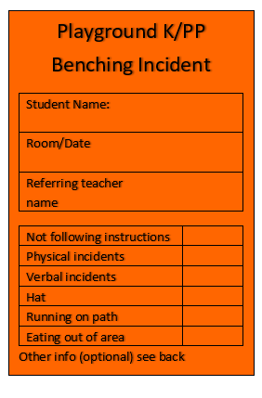
Referral Forms
Orange slips – K-PP
For minor playground incidents an orange slip is completed, the child receives some time out of their playtime and is required to sit on the bench in time out. The slip is passed to the child’s teacher.

Blue slips – Yr. 1 - 6
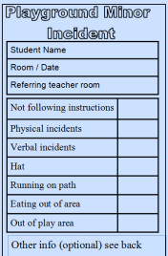
For minor playground incidents a blue slip is completed and passed to the child’s teacher. If students receive 3 blue slips in a term they are then referred to Administration.

Pink slips – anytime
If a student has worked their way through the Ready To Learn chart (dark red) or, has escalated to more severe behaviours staff will complete a pink slip which involves an Administration referral. This can be during class or at any other time.

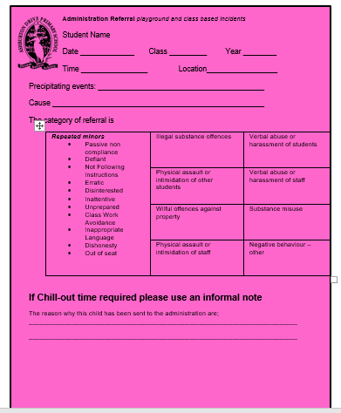

Caregivers are informed of unproductive behaviours through an via a phone call. We request that you acknowledge the receipt of this letter by signing and returning it the following day. There is also the opportunity to discuss this with staff, which is detailed on the letter.

Some possible consequences for students receiving a pink slip (or 3 blue slips leading to a pink slip)
- Removal from class for a period of time, as required, to allow them to reset
- Detention (the child misses a recess or lunch play and will discuss with staff how they can improve their behaviour next time)
- Children are encouraged to apologise, if appropriate
- Possible additional support to be put in place with the student if required and appropriate e.g. school councillor, additional in class support etc.
- Not all consequences are listed here, as each situation is evaluated according to the situation and needs of each child

How do I find out what WA PBS lessons are being taught at ADPS?
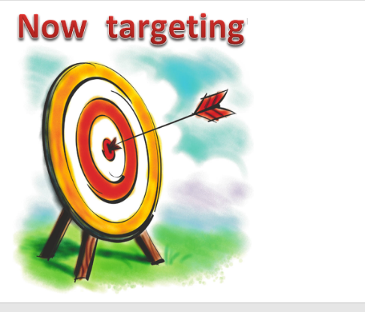
- WA PBS noticeboards are placed around the school.
- The “Now targeting” boards indicate our expectation of the fortnight in each class.
- Discuss with your child
- Assembly announcements
- Parent newsletter

Student Voice Committee
One student per class from Years 3-6 is selected to meet and discuss topics linked to W.A. PBS. They represent other students by liaising with them and giving feedback in meetings. These are led by a staff member of the ADPS W.A. PBS committee, who provides this information to the W.A. PBS team. Committee members have a one-year membership and may be re-elected.
The criteria for the Student Voice Committee are:
- Consistently uphold the ADPS values
- Is able to keep up with their class work
- Has good communication skills with adults and other children
- Has a positive attitude
- Is motivated
- Has a growth mindset
- Likes to share ideas
- Shows leadership qualities
- Does not already have another role in the school

School mascots linked to values
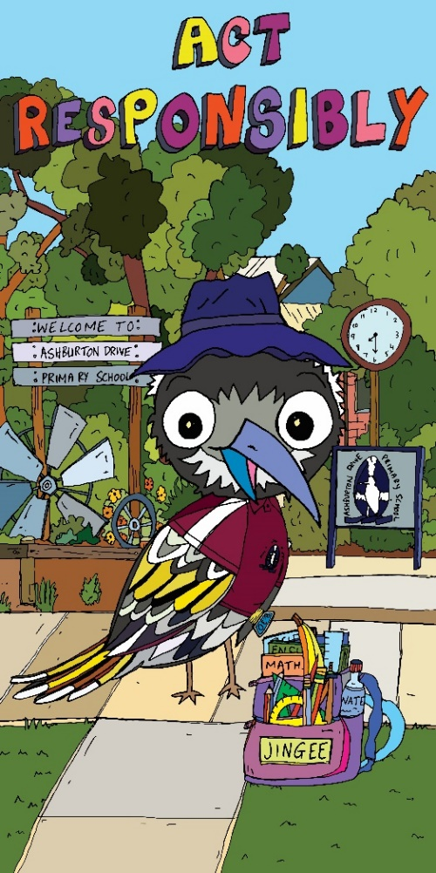
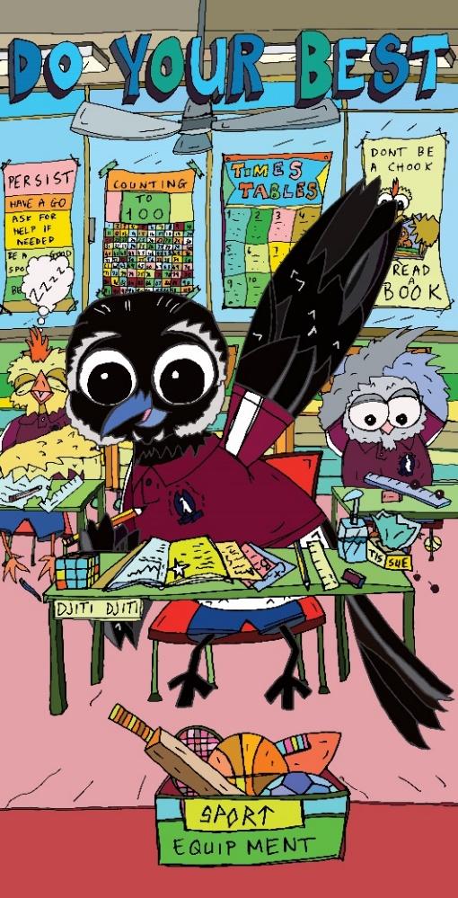

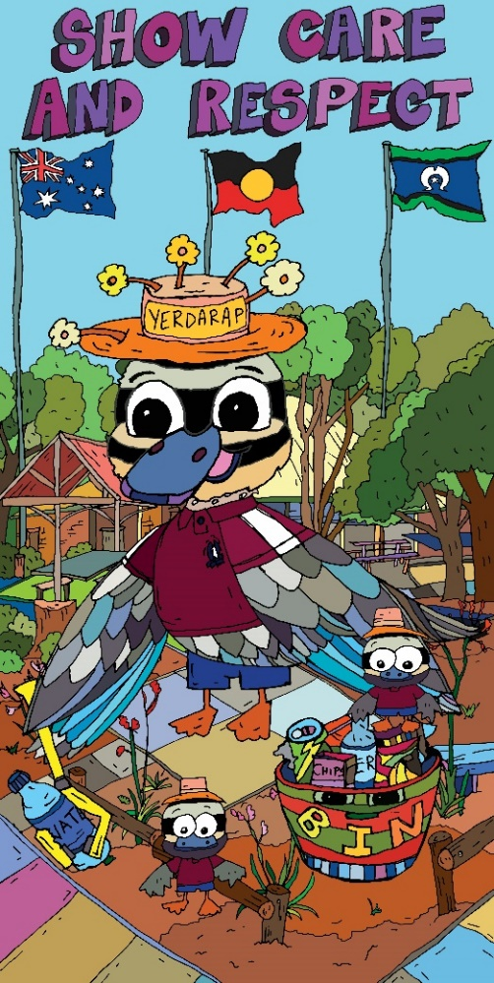
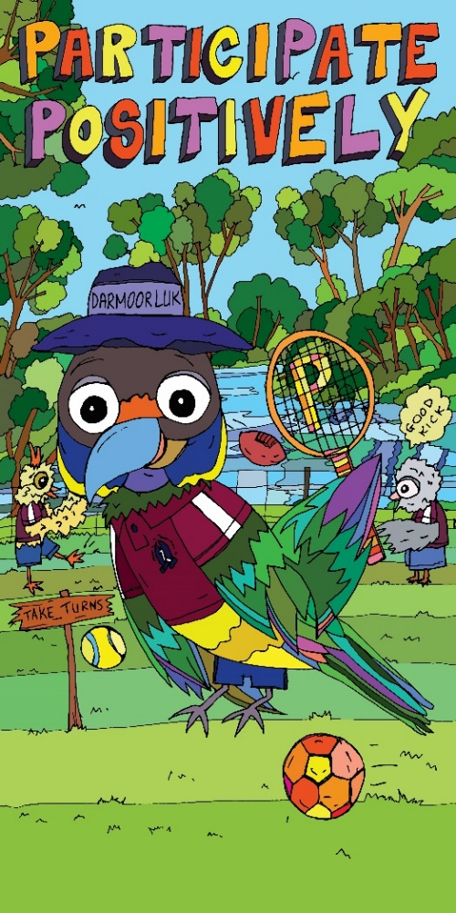

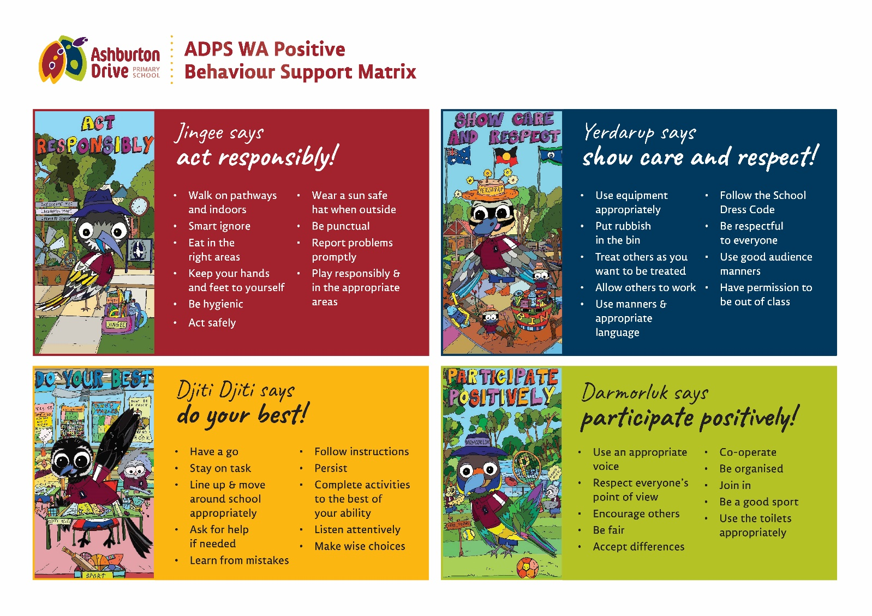
How do I communicate with the school in relation to WA PBS if I have a suggestion?
There is a dedicated W.A. PBS committee in school that meets regularly to discuss behaviours and approaches. If you have any general ideas please e-mail the school on,
AshburtonDrive.PS@education.wa.edu.au marked for the attention of the W.A. PBS committee.

Please note - this is not for discussion of specific students. If you have any specific concerns, please contact Administration directly.
Please see the ADPS behaviour support policy available from our school website or available from the school office for more detailed information.
https://www.ashburtondriveps.wa.edu.au/our-school/policies/

