
A dynamic, inclusive learning community striving for excellence
2026
Behaviour Support Policy and Procedures

Ashburton Drive Primary School 

Table of Contents
Introduction 2
Links to Department of Education (DoE) Policy 2
WA Positive Behaviour Support (WA PBS) at our school 3
School Code of Conduct 4
Seven Essential Components of the WA PBS Framework 4
Student Behaviour Support Levels of Intervention 7
Behaviour Support Flowchart 2
Good Standing Policy 3
Strategy for deciding on consequences 3
Department policy for withdrawal/ suspension 4
Physical restraint of a student 9
Bullying 11
Aggression 11
Drug and alcohol misuse by students 12
Presence of weapons on school sites 12
Risks of suicidal behaviour and/or non-suicidal self-injury 14
Personal use of mobile and other electronic devices 14
Cyber Safety 16
Record keeping and use of data in assessing the effectiveness of whole school behaviour support 16
Ongoing Review 17
APPENDIX 1 – ADPS WA PBS Matrix 18
APPENDIX 2 – Special Educational Needs (SEN) Process chart 19
APPENDIX 3 – Ashburtoken System Chart 20
APPENDIX 4 – Personal Best Information for Parents 21
APPENDIX 5 – Anti-Bullying information for parents 22


Ashburton Drive Primary School
Behaviour Support Policy and Procedures

Introduction
This Policy has been developed to articulate our school beliefs and processes about behaviour support at Ashburton Drive Primary School (ADPS).
Through the policies and procedures outlined in this document we will be working to achieve our school vision of “A dynamic, inclusive, teaching and learning environment, empowering students to achieve personal and academic growth.”.
Our purpose is to develop and implement school-wide WA PBS in order to improve behaviour, teach social skills and foster a positive attitude towards learning to achieve higher educational outcomes. It is our intention that this will develop a school culture which is consistent and based on a common language which is used by all.
In this document, “the principal will…” means that it is the principal’s responsibility, as site manager, to manage its implementation. It does not mean the principal must personally undertake the duty. The principal is responsible for what must happen but has discretion over how it happens on the site.

Links to DoE Policy
Department of Education (DoE) schools provide every student with the educational support the student needs to learn and maintain positive behaviour.
ADPS seeks to implement this through WA PBS, consistent and clear expectations and a school wide approach to managing and responding to unproductive student behaviour.
ADPS builds a school community in a co-design process to develop, document and communicate.
ADPS develops, implements and monitors a whole school approach to behaviour by:
- Identifying and communicating the rights and responsibilities of all students and staff
- Incorporating restorative principles, systems and approaches
- Providing multi-tiered systems of support
- Building staff capability through training and support
- Providing behaviour support to students with complex needs
ADPS retains records regarding consultation, intervention strategies and case management plans.

WA Positive Behaviour Support (WA PBS) at our school
Improving student academic and behaviour outcomes is about ensuring all students have access to the most effective and accurately implemented instructional and behavioural practices and interventions possible. WA PBS provides an operational framework for achieving these outcomes.
WA PBS builds a continuum of supports for staff and students. At each level (or tier) there is an emphasis on outcomes in the form of agreed expectations for student and staff behaviour, and data to guide decision-making about the practices put in place to support student learning and social behaviour. There is equal emphasis on the system supports that will be needed to build fluency with new or revised practice among all teachers and staff within the school.
WA PBS is supported by a three-tiered model as follows:

Tier 3 | Intensive practices and systems for students whose behaviours have been documented as not responsive at tiers 1 and 2. Individualised to the specific needs and strengths of the student.
Tier 2 | Specialised practices and systems for students whose behaviours have been documented as not responsive at tier 1. Generally provided in a standardised manner in small student groupings.
Tier 1 | Practices and systems for all students and staff implemented across all school settings.

School Code of Conduct
Our school community values are:

Act responsibly
Do your best
Participate positively
Show care and respect

Roles and responsibilities of staff in implementing whole school behaviour support
Staff have a responsibility to:
- Model respectful, courteous, and honest behaviour as required by the ‘Code of Conduct’ and Standards and Integrity’.
- Model and adhere to explicitly taught values and lessons as positive role models.
- Ensure good organisation and planning.
- Explicitly teach lessons from the WA PBS Programme to ensure children understand how to comply with expectations.
- Report student progress in behavioural matters in keeping with the DoE requirements.
- Plan, consult with the school community and implement documented plans relating to behaviour, engagement and/or risk management plans as appropriate for students with complex needs.
- Collaborate with colleagues to ensure whole school practices are implemented.
- Ensure that the school environment is kept secure, neat and tidy.
- Establish positive relationships with students and parents, including culturally responsive practice.
- Respond to behaviours of concern that are harmful to self, and/or others and/or to the school environment.

Positive behaviours are taught to develop a student’s competence and capacity to:
- Recognise and regulate their own emotions.
- Develop empathy for others and understand relationships.
- Establish and build positive connections with adults and peers.
- Make responsible decisions.
- Work effectively with others.
- Cope with challenging situations.

Seven Essential Components of the WA PBS Framework
The ADPS WA PBS Framework utilises the 7 essential components of the WA PBS framework to develop a common philosophy and approach to supporting student engagement at school.
- Leadership
The WA PBS leadership team leads the school through a process of developing and gaining consensus on beliefs, expectations and procedures along with a written plan.

The WA PBS committee at the school has been established to lead the implementation of Positive Behaviour Support at ADPS. The WA PBS committee comprises the Principal, Deputy Principal, staff members representing each phase of development – teaching and non-teaching - and may also include student and community members.

- Defining Expected Behaviour
Our school behaviour matrix outlines expected positive behaviours to our students (Appendix #1). Teachers set expected behaviours by establishing classroom rules, in line with the behaviour matrix. These are frequently reinforced through classroom discussion and the modelling of expected behaviour.

- Teaching Expected Behaviour
Systematic teaching of the pro-social behaviours is a routine part of the school day using the same methods as teaching academic skills, through modelling, practice, and feedback. Staff at Ashburton Drive PS explicitly teach expected behaviours with weekly lessons which have been developed using the iSTAR format. A whole school approach is used where all classes teach lessons around a focus area determined by the WA PBS committee. These foci are publicised throughout the school including the school newsletter, assemblies, PA announcements and staffroom planning board, to ensure all staff and students are aware of the fortnightly focus. Staff also choose a focus based on classroom needs.

- Encouraging Expected Behaviours
Staff provide regular feedback to students about their behavioural progress, creating a school culture where pro-social behaviours are the norm. Staff are committed to encouraging expected behaviours through signage, reward systems, reinforcement, explicit and incidental teachings.

- Engagement Strategies
Staff utilise engagement strategies to increase academic learning time and ultimately student engagement, while ensuring a positive and welcoming learning environment. These practices represent the facets of classroom teaching that have been identified as evidence-based practices to maximise learning for all students while minimising discipline disruptions. Ashburton Drive PS ensures the safety of students through restorative practice and various scaffolding programs such as Breakfast Club, School Chaplain, Individual Plans, Attendance Plans and Student Support Services.

- Responding to Unproductive Behaviour
Unproductive behaviour also requires feedback and is viewed as a teaching opportunity – a chance to clarify and re-teach expectations. The same calm, instructional approach used when students make academic errors is used to correct behavioural errors. The development of a continuum of responses to behaviour provides staff with the tools to effectively respond to, and redirect, student behaviour.
See Appendix 2 SEN Processes Chart

- Ongoing Monitoring
The use of data focuses staff efforts by identifying areas in need of improvement as well as those operating well. Monitoring rejuvenates processes and practices by providing feedback or knowledge of results that promote consistent implementation and renewal. At Ashburton Drive Primary School data is used to monitor student behaviour and the WA PBS implementation process.

A Student Voice Committee comprising of one elected student from each Year 3-6 class meet weekly to ensure a culture where students have a voice in decisions that affect them, students leading to students being welcomed, safe and experiencing belonging.

Student Behaviour Support Levels of Intervention

Who may be involved?

Student Behaviour Support Levels of Intervention

Strategies at Tier 1

Winning over:
- Politeness
- Greet students at the door
- Personal interest
- Use of names
- Smile
- Humour
- Enthusiasm
Belonging:
- Safe environment
- Inclusiveness
- Parental engagement and communication
Low key responses:

- Signal to begin
- Transitions
- Type of response
- With-it-ness
- Proximity
- Scanning
- Body Language
- Facial Gesture

Instructional/Engagement Strategies:

- Lesson design
- Cooperative learning
- Framing questions/ feedback
- Active participation
- Breakfast Club
- School Chaplain
- Student Support Services
- Attendance Plans
- Restorative practice
- Reward Systems
- Parental communication
- Social and emotional curriculum
- Teaching for Impact suite of resources

Strategies at Tier 2

– continue with strategies from Tier 1 +
- Count on ‘Ready to Learn’ chart
- Emotion coaching
- Smart ignoring
- ‘Square off’
- Either/or choice
- Implied choice/ contract
- Functional Behavioural Analysis
- Development of Documented plan (May include Individual Behaviour Support Plan, Emergency Response Plan, Risk Management Plan)
- Parent contact, where necessary

Strategies at Tier 3

– continue with strategies from Tier 1 & 2 +
- Counselling
- Case Management
- Functional Behavioural Analysis
- Parent engagement
- Suspension/ Re-entry meeting/plan
- Development of documented plan (may include IBSP, Emergency Response Plan, Risk Management Plan)
- Detention/Withdrawal
- Psychologist referral for further investigation (Functional interventions)
- Referral to external agencies (e.g., SSENBE)

Behaviour Support Flowchart
All teachers have their own classroom behaviour support plans, including rewards and consequences. They include explicitly teaching students they have a choice when deciding on their behaviour, promoting personal responsibility and accountability for behaviour across the community. Expected behaviours are taught and modelled through weekly WA PBS lessons. The following responses to behaviours of concern are solution focused and seek to repair damaged relationships. They are applied with procedural fairness to decision making, prioritising the safety and wellbeing of all school members.

Communicating to parents on students’ behaviour

Positive Behaviour
Teacher/Administration contact with guardians Attendance awards/medallions
Class Dojo points Ashburtokens/Try-Athlon Certificates
Class rewards/awards Merit Certificates and assembly awards
Green letter from administration Termly Personal Best reward
Graduation awards Good Standing Status

Good Standing Policy
The Good Standing Policy to follow is a DoE directive as outlined in the ‘Standing Together Against Violence' Ministerial document.
Clear expectations of student behaviour are outlined in this policy and the WA PBS Booklet. Students will automatically have Good Standing while exhibiting behaviours that align with our values and beliefs. The move to Conditional Standing will be decided by the Principal in consultation with staff and the implementation of an Individual Behaviour Plan. It is the responsibility of each student to maintain his or her ‘Good Standing’.
Activities and roles that require Good Standing include (but are not limited to): Student Councillor, Sports Captain, Choir member, Puppets and Clowns member, interschool sports participant and identified incursions and excursions, including any P and C events. Please note: excursions and incursions are part of the curriculum and generally will NOT be Good Standing events.
Loss of Good Standing occurs after a withdrawal, suspension, or series of detentions (3 or more) in one term, that are not aligned with the school code of conduct. These behaviours may include, but are not limited to:
  - starting a fight
  - making physical contact with the intention to harm another
  - filming a fight

Students who breach the school code of conduct will have privileges removed, such as being banned from school social activities and/ or loss of student leadership role. Appropriate educational instruction will be provided if the student is not permitted to take part in school events during school instruction time.

Student Leadership and Good Standing: The first time a student leader loses Good Standing they will lose their badge and their right to represent the school until they are reinstated. Should this occur a second time the right to represent the school, as a student leader, will be removed for the remainder of the year.

Parents will be notified if a student moves to Conditional Standing. This will be a shared responsibility and expectation, in partnership with students and carers. The Individual Behaviour Plan will have targeted behaviours clearly stated with identified reward and consequence processes to follow. Outcomes will be measurable to achieve success in behaviours and a return to Good Standing.
Re-instating Good Standing: A restorative approach will be utilised to re-establish positive behaviour. A ‘Good Standing Passport’ will be issued which requires the student to engage in positive interactions and adherence to school values and processes consistently for a two-week period.
Unproductive Behaviour Communication steps
Teacher/Administration contact guardian concerning:
- the reason for the loss of Good Standing.
- What withdrawal means for the student.
- The plan to improve the student’s behaviour.

Student supports focus on:
- Rebuilding and repairing the relationship.
- Supporting the student to reflect on their actions and to consider perspectives of others.
- Identifying any unmet needs and providing behaviour support to reduce a recurrence of the behaviours of concern.
- Providing a clear and achievable pathway for the student to regain Good Standing.

Strategy for deciding on consequences
When deciding consequences, the school will take individual situations and student needs into account.
When a referral is made, Administration staff:
- Check all students involved are safe, physically and emotionally (de-escalated).
- Establish the facts by investigating what has happened, taking the time to interview all students involved and other witnesses if necessary.
- Utilise restorative practices when appropriate and timely, to rebuild relationships.
- Apply consequences based on a variety of factors which may include, type and severity of incident, opportunity for learning positive behaviours and frequency.
- Record information according to DoE Processes and share information on outcome of referral with admin team and relevant staff.
- Contact parents if deemed necessary (via phone or letter home). Confidentiality is maintained by only sharing information with parents that is relevant to their own child.

Withdrawal
Withdrawal of a student from classes, breaks or other school activities:
School administrators (see regulation 41 of the School Education Regulations 2000) may withdraw a student from classes, breaks or other school activities as part of a school’s planned behaviour support response for no longer than 5 days. Applied as close as possible to the time of the breach of school discipline, withdrawal is used for the purpose of providing an opportunity to:
- calm in circumstances where the student has become unable to self-regulate; and/or
- reflect on and learn from the incident, including where appropriate engaging in restorative processes; and/or
- continue a learning activity in a less stimulating environment.

Behaviours of concern for which a withdrawal would be used include:
- stealing.
- continuous disruption to classroom routines (once all other avenues have been utilised).
- refusal to comply with school rules.
- repeated low level physical acts.

When a student is withdrawn, the school administrator will:
- Ensure the withdrawal is proportionate to the breach.
- Ensure the withdrawal is informed by the student’s cultural, cognitive, developmental and psychological background.
- Ensure the withdrawal has the minimum possible impact on the student’s academic progress, engagement and connectedness.
- Provide oral or written advice to the parent(s) that day, or as soon as possible thereafter, about the withdrawal. SMS notification is sufficient to satisfy this requirement.
- Ensure that location and supervision arrangements account for duty of care.
- Ensure that the student is provided the opportunity to complete assignments or assessments to fulfil course requirements.
- Create a record for each student withdrawn showing:
  - reason for the withdrawal
  - date, time and duration of the withdrawal
  - notification to parent

Approaches to support the student focus on:
- rebuilding and repairing the relationships.
- supporting the student to self-reflect.
- support the student to consider perspectives of others.
- identifying any unmet needs and providing behaviour support to reduce a recurrence of the behaviour of concern.

Suspension
Understand Suspension
Suspension is used when a breach of school discipline has:
- adversely affected or threatened the safety of anyone on the school site, or taking part in an education program.
- caused, or are likely to result in, damage to property.
- disrupted the educational instruction of other students.
Suspension is an opportunity for:
- the student, other students and staff to calm and recover.
- everyone to reflect on, and learn from, the incident, including where appropriate participating in restorative processes.
- the parent to meet with the school to discuss how to improve coordination between school and home to help the student behave appropriately at school.
Suspension also gives school staff the opportunity to:
- Re-establish the good order of the school.
- Evaluate the effectiveness of the student’s existing behaviour support plan.
- Meet with any internal or external stakeholders who can support the student.
- Identify and plan supports and adjustments that may be required.
When suspension can apply
Number | Category name | Description of behaviour
1 | Physical aggression toward staff | Aggressive physical contact committed intentionally against staff.
2 | Abuse, threats, harassment or intimidation of staff | Verbal or non-verbal actions that are abusive, harassing, intimidating or threatening, including stalking, sexual harassment, sexual innuendo and manipulation.
3 | Physical aggression toward students | Aggressive physical contact committed intentionally against another student.
4 | Abuse, threats, harassment or intimidation of students | Verbal or non-verbal actions that are abusive, harassing, intimidating or threatening, including stalking, sexual harassment, sexual innuendo and manipulation.
5 | Damage to or theft of property | Direct or indirect damage to, or theft of, property.
6 | Violation of your school’s code of conduct or school or classroom rules | This covers student misconduct not addressed in any of the other categories that violate the school’s code of conduct.
7 | Possession, use or supply of substances with restricted sale | This category covers use or supply of substances such as cigarettes, alcohol and prescribed medicines, that are not in themselves illegal, but the sale of which may be restricted to persons over 18.
8 | Possession, use or supply of illegal substance(s) or objects | The substances referred to in this category are those that are illegal under the Criminal Code Act Compilation Act 1913 (WA). This includes weapons and illegal drugs.
9 | Other
0 | E-breaches | Breaches under the Students Online in Public Schools policy and procedures or personal use of mobile electronic devices requirements. This includes breaches of an acceptable use agreement, appropriate use of online services agreement, and recording, distributing or uploading of inappropriate images or messages of students, parents or staff with reasonable link to the school.
Principals must apply an automatic suspension and loss of good standing to any student who either:
Attacks or initiates a fight with another student.
Records, publishes or uploads to social media a video of fighting or bullying involving students of a public school.

The decision to suspend
- Only the principal has authority in the school to make a decision to suspend a student. This authority cannot be passed to another member of staff, except to a school administrator (Deputy Principal, Acting Principal, Acting Deputy Principal) in circumstances where the principal is unable to exercise the suspension. This temporary transfer of power is required to be authorised in writing, either prior to the circumstances arising or at the time, before the school administrator may exercise the power to suspend. Where the principal is unable to provide this written authorisation, it may be provided by the Regional Executive Director.
- Where the breach of school discipline is considered by the principal to be a serious breach, the principal will assign a provisional suspension period, and shorten or lengthen this period, subject to Regulation 43(1)(b), upon completion of an investigation into the incident.
- Under regulation 44 of the School Education Regulations the reasons for suspension will be discussed with the student and parent so they are aware of the behaviour of concern and the sanction that is being imposed.
- The principal will provide the student and parent a reasonable opportunity to give reasons against the decision to suspend and/or the length of the suspension.
  - For serious breaches of school discipline, this will occur in writing as soon as practicable after the provisional suspension decision.
  - Re-engagement support planning will occur with the student, parent and other relevant stakeholders as needed.
- An alternative strategy to suspension will be considered by the principal where:
  - the principal has reason to believe that the student will be exposed to serious safety risks (e.g. physical or sexual abuse, exposure to drugs, crime or domestic violence, homelessness) outside of the school and reasonable measures to mitigate these risks to the student cannot be arranged; or
  - the student is considered by the principal to be at risk of suicide or serious non-suicidal self-injury, and the principal is not satisfied that there are arrangements for sufficient supervision/care for the student outside of the school.
  - In such circumstances, the record should state the degree of seriousness of the breach and that the strategy was used in lieu of suspension due to exceptional circumstances.
- The principal will not allow a suspended student to leave the school grounds before an agreement has been reached with the student’s parent for how the student will get home. This must occur on every occasion, as it involves a transfer of duty of care from the school to the parent. Where it has not been possible to reach such an agreement, and the student is continuing to pose a risk to staff, students or property, the principal should consider calling the police to request that the student be removed.
- Where a parent is not able to pick the student up and asks that the student be allowed to walk home, the principal will not allow the student into the community if the student is in an escalated state such that risk of harm to the student, community members or property is reasonably foreseeable. The principal will take reasonable measures to calm the student before the student leaves the school grounds without a parent.
Recording the decision
- The principal will:
  - enter the suspension into the school's information management system as soon as practicable following the decision to suspend.
  - enter a report into the Online Incident Notification System (OINS) for any incident:
    - deemed by the principal to have involved a serious breach of school discipline.
    - involving a notifiable incident, as defined in the Emergency and Critical Incident Management policy.
  - record all absences due to suspension as authorised absences using the Z code.

Requirements in addition to those stipulated in School Education Regulations 43-46
- The principal will take reasonable measures to minimise the number of days any one student is suspended for during the course of a school year. Where repeated suspension is not proving effective as a strategy to reduce the severity or frequency of breaches of school discipline by a student, the principal will consider other strategies that may be more successful.
- The principal will not consider the reaching of a specified number of days of suspension to be an automatic trigger for exclusion.
- For the purpose of calculating suspension periods, the principal will consider each day the school is open for business as counting for a whole day within the student’s suspension period. This requirement applies irrespective of the student’s normal level of attendance on that day, including where:
  - the student would normally be absent from school that day due to a Notice of Arrangement or placement in an off-site program; or
  - the suspension applied is for only part of the school day. It is not intended, however, to mean that a student, who is sent home at lunchtime for the remainder of the school day, should have a whole day suspension recorded.
- The principal will consider multiple breaches in the course of an incident or connected series of incidents to be taken as one overall breach for the purposes of considering the case for and duration of a suspension.
- The principal will not apply suspension for reasons associated with:
  - attendance
  - an incident occurring outside of school, except where the principal can establish a reasonable nexus between the incident and the school; or
  - dress code
- The principal will not apply a suspension period that exceeds the number of days remaining in the school term. For purposes of accurately reflecting the severity of the student’s breach of school discipline, the principal may express in the record of the suspension decision the length of suspension that would otherwise have been applied.
- The principal will not extend suspension periods into the following school term.
- In circumstances where the time left in the school term is insufficient reasonably to investigate an incident and reach a decision on a suspension, the principal may make the decision at the beginning of the next school term.
- Under regulation 43 of the School Education Regulations, the maximum allowable period of suspension for a:
- breach of school discipline is 5 consecutive school days.
- serious breach of school discipline is 10 consecutive school days.
The principal’s responsibilities during and immediately following the suspension period:
- Wherever practicable the re-entry meeting to prepare the student to return to school will be conducted before the suspensions ends.
- When a student comes onto school grounds without permission during a period of suspension, the principal will:
  - ascertain the reason for the attendance and offer the student assistance when the reason for attendance is genuine.
  - where the student does not supply a genuine reason, discuss calmly and supportively with the student the need for the student to honour the suspension decision and leave the school grounds.
  - make reasonable attempts to notify a parent to collect the student in circumstances where the student refuses to leave school grounds.
  - notify the police if the student is acting in a way that poses a threat to staff, students or property.
- For a student who commits a breach of school discipline while on suspension, the principal may apply an extension to the suspension period, subject to Regulation 43.
  - Where the maximum period of suspension is already in place, the principal will consider alternative disciplinary sanctions for that breach, to be served after the student’s return to school provided that this sanction does not further limit the student’s attendance. This does not apply in the event of a recommendation for exclusion.
  - A suspension under Regulation 43(1)(a) may not be extended to a suspension under Regulation 43(1)(b), except where the breach committed during the suspension period can reasonably be considered by the principal to be a serious breach.
- The principal will provide a learning activity for the student to complete during the period of suspension where this period is for 3 or more consecutive days or totals more than 5 days in the school year (this is not dependent upon the parent or student asking for work to be provided). The principal will:
  - provide work that is a genuine learning activity designed to assist the student to maintain their learning which is able to be completed without staff supervision.
  - Where the period of suspension is less than that stipulated in Section 21 above, the principal will make reasonable endeavours to ensure the student keeps up with their classwork and maintains continuity of learning.
- If a student accumulates 8 suspensions or 20 days of suspension in a calendar year, whichever comes first, the principal will:
  - inform the Regional Executive Director and Principal, School of Special Educational Needs: Behaviour and Engagement as part of a case management approach.

Physical restraint of a student
Physical restraint of a student is used as a last resort, and only as either:
- a planned, documented, approved strategy.
- an emergency response.
Regulation 38 of the School Education Regulations 2000 (WA) provides that school staff can take reasonable action to either:
- manage or care for a student.
- maintain or re-establish order.
- prevent or restrain a person from placing at risk the safety of self, others or damaging property.
Physical restraint of a student is only used if the student’s behaviour:
- prevents other strategies from being successfully used to maintain the good order of the learning environment.
- poses imminent risk of harm to themselves or others, or significant damage to property.
Physical restraint must only be used for the minimum amount of time needed for the student to recover to behaviour where less restrictive strategies may be successful.
Some situations may require physical contact to support instruction, manage health care needs or maintain the safety of students, staff or the school environment.
Principals must consider:
- the student’s rights and freedom of movement.
- the student’s cultural, cognitive, developmental and psychological background.
- the functions of the student’s behaviour.
- environmental factors contributing to the student’s behaviour.
- information and advice from the parent, school staff, student support services and relevant external agencies.
The principal will provide appropriate support to the student, staff, other students and parents as required after the restraint.
The principal will keep a record for each instance of physical restraint, which includes:
  - date, time, location and duration of the physical restraint.
  - name of student and name(s) of staff member(s) involved.
  - reason for the physical restraint.
  - de-escalation strategies attempted prior to application of physical restraint.
  - follow-up support provided.
  - detail of contact with the parent.
  - a statement by the staff members involved.
  - whenever possible, a statement by the student involved.
The use of physical restraint must be set out in the student’s documented plan, developed as part of a case management process. An exemption to this is when it is required to be used in an emergency situation to protect a student from harming themselves or others.
A report will be lodged via the, internal, Online Incident Notification System as soon as practicable after the incident.
A principal will only authorise a plan to apply physical restraint as an ongoing strategy for a student when the documented plan:
- is developed with and regularly reviewed in consultation with the parent, and other stakeholders, such as:
  - the student
  - school staff
  - specialist services including the School Psychology Service, the Schools of Special Educational Need, and any external agencies or practitioners identified by the parent.
- involves a hierarchy of planned culturally and developmentally appropriate responses that focus on prevention and early intervention to minimise and eliminate the use of physical restraint.
- involved strategies to support and develop areas of current needs.
- considers the safety and wellbeing of the student, including the risk of the restraint causing physical or psychological harm.
- identifies any medical or psychological conditions the student has that may make physical restraint harmful to the student.
- includes how to maintain the dignity of the student.
- considers the likely response of the student.
- provides information about the type and use of restraint.
- defines the situations in which restraint will, and will not, be considered.
- considers the safety of staff members and other students, including whether restraining a student in a state of extreme escalation will likely cause them to make physical contact with staff.
- identifies the staff who are willing and trained to use approved de-escalation and positive handling techniques.
- incorporates ongoing review, noting that the use of restraint should be reviewed following each use.
The principal will take reasonable measures to:
- include planned restorative approaches for the student and others following the use of restraint.
- review use and consider any de-escalation and positive handling strategies that might reduce the likelihood of a future occurrence.
- ensure that De-escalation and Positive Handling training remains current.

The principal will monitor the effectiveness of physical restraint as part of the behaviour support strategy.

Bullying
Bullying is a learned behaviour that is unacceptable and can have long-term harmful impacts on students’ school engagement, academic achievement, wellbeing, physical health, and mental health. However, bullying behaviours can be changed.
At Ashburton Drive Primary School we are committed to providing a safe and inclusive environment for students and fostering a harmonious school community. Therefore, we do not accept bullying or harassment in any form.
Students learn and clarify the definition of bullying vs conflict through explicit teaching (ISTAR lesson plan).
Confirming whether the behaviours were intentional is not required to implement the strategies for responding effectively. It is important to act as a result of the effects on the targeted individual, immaterial of the determination of intent.
Bulling can include verbal bullying, social/relational bullying, physical bullying, cyber bullying and bystanders.
Preventing Bullying
Bullying prevention is everyone’s responsibility. Please refer to Appendix 6 for the Rights and Responsibilities created by Bullying. No Way!
Whole school prevention strategies utilised at ADPS are and not limited to:
- Promoting a whole-school student support approach with shared leadership.
- Promoting collaborative relationships between the school, parents, and the wider community on developing and implementing school-based strategies.
- Developing a positive whole-school plan based on the teaching and recognition of respectful behaviour.
- Developing a shared understanding of what behaviours constitute bullying, the impact of bullying, safe and supportive bystander responses, positive social problem-solving skills.
- Promoting a school culture that seeks to be proactive and restore relationships affected by persistent or unresolved conflict.
- Promote Respectful Relationships.
- Promote positive staff role modelling; and
- Ensure the plans or policies are monitored, reviewed, and refined regularly and collaboratively.
Responding to Bullying
We have established a restorative approach to responding to bullying behaviours. Restorative justice approaches are a way of thinking and interacting that puts relationships at the centre of all actions and decisions. Restorative approaches are empathic, responsive to need, view conflict as opportunities to learn and grow, and build accountability for actions and processes to repair harm.
Our school provides consistent and clearly articulated procedures for responding to incidents of bullying. These are to be followed by teachers as a guide and can be added or skipped depending on individual situations – in line with the whole school Anti-Bullying policy.
- Acknowledge the student/s by actively listening to the issue. This involves asking clarifying questions.
- Interview all students that need to be questioned to gain a deeper understanding of the situation.
- Decide what action needs to be taken. Follow school procedures i.e., for playground behaviours issue a slip, for classroom behaviours move on Good Standing board, reflection sheet etc. Low level incidents that should be handled by teachers including:
  - Bumping
  - Staring
  - Pushing
  - Spreading rumours
  - Social isolation
- For more severe incidents refer to an administrator. Ensure that documentation will be completed by either teacher or an administrator where appropriate.
  - Severe incidents that must be reported immediately to admin.
    - Physical assault
    - Racist or discriminatory comments
    - Sexual comments
- Notify relevant stakeholders (admin, class teachers, parents) of issue, action taken and resolution where appropriate. Refer student/s for relevant counselling e.g., school psychologist, chaplain, 3-way conference, administration.
- Ensure to follow-up with the student/s to see that the issue has been resolved.
- Document incident, action and follow up.

Aggression
Teachers have a duty of care towards all students and are required to ensure a safe learning environment. On occasions, challenging and violent behaviour from some students will compromise safety and the opportunity for other students to learn.
In consultation with admin staff and parents/caregivers, teachers will develop behaviour support and risk management plans for students who present with such challenging behaviours.
When students present with violent behaviour or aggression:
- If the incident is urgent, critical and dangerous, contact the police through the school principal.
- Restrictive practices, such as restraint, should only be used as a last resort and be part of a documented plan.
- In such cases, and in all other cases where restraint is used, the principal or delegate will submit an online incident notification.
- Report incident with an AIIR and/or PIIR.
- Complete a risk assessment including consultation with the health and safety representative.
- Consult with the parents, the school psychologist and the student services/support specialist to develop a documented plan.
- To reduce the risk of injury the following practices are investigated; Tier 3 requests of support, Team Teach training, accessing resources – such as Code of practice: Violence and aggression at work, manage working alone risks.
- Provide staff with ongoing support including applicable agencies.
Types of violent and aggressive behaviour
- Threats of violent acts
- Verbal abuse
- Defamatory or inappropriate personal comments
- Physical contact
Threats of violence can result from:
- Face-to-face interactions.
- Electronic means, including comments on social media.

  - Drug and alcohol (including vaping) misuse by students, including provision of evidence-based drug and alcohol education
Drug and alcohol education will form part of the schools Health Education Curriculum in line with SCSA Western Australian Curriculum requirements. Resources to teach these will be in line with DoE and relevant health authority evidence-based approaches as well as the school’s WA PBS and resilience programs. These programs will be re-evaluated and revised as updates become available.
The possession or use of illegal substances by students at school is not acceptable under any circumstances.
Being intoxicated does not excuse a breach of school discipline by a student. However, a breach of school discipline committed by an intoxicated student must be dealt with only after the safety and wellbeing of the student has been secured.
Student intoxication on school sites or at school off-site activities is unacceptable. Staff will respond swiftly and consistently wherever a student is reasonably suspected of being intoxicated including contacting the parent.
These requirements relate to school disciplinary considerations only and are not a complete guide for dealing with drugs or alcohol use by students. Drug and alcohol use by students will be responded to through health and education frameworks. In circumstances where school staff have reasonable grounds for belief that a student is intoxicated, the immediate priority will be the health and welfare of the student. A follow up priority is support and education for the student. This serious breach will be responded to through the suspension information provided.
Under regulation 71 property can be confiscated if it is disruptive, adverse to safety or could cause damage. The property is then delivered to the principal who will arrange collection by a parent (unless property has been delivered to the custody of police).
The Principal has the authority to deliver directions to any party on site. It is the responsibility of the principal to report relevant matters to the police.

Presence of weapons on school sites
A weapon is anything:
- serving as an instrument for making or repelling an attack.
- that can be made or modified to be used to injure a person.
- that can cause a person to fear that someone will be injured.
Prohibited weapons are any item that has no purpose other than as a weapon, such as spray weapons, flick knives or switch blades.
Controlled weapons include those used in the practice of a martial art, act, sport, or similar discipline, such as imitation firearms, swords, machete or spear guns.
Firearm includes any lethal firearm and any other weapon of any description from which any shot, bullet or other missile can be discharged or propelled, such as handguns and paintball guns.
Students are not to be in possession of weapons on the school site or at any school activity. A student who is aware of a weapon on the school site or school activity, must bring this information to the attention of school staff.
Incidents involving weapons must be dealt with as a serious breach of school discipline and the student must be suspended immediately under regulation 44(2).
Students who bring a weapon to school:
- could be in a serious breach of school discipline.
- may also have committed a criminal offence under the Weapons Act.
Where there is ‘reasonable suspicion’ or it is known that a student is in possession of a weapon, school staff will:
- assess the level of risk to the student and others.
- report the matter immediately to the principal; and
- ask the student to accompany a member of school staff to the school office or another predetermined safe location where the principal or nominee, together with a witness, will request that the student hand over the weapon.

If the student declines to hand over the item which is likely to cause harm, in the presence of a witness, the principal will:
- inform the student’s parents/carers of the situation.
- give the parent/carer an opportunity to speak with the student on the telephone or to attend the school to speak with the student; and
- ensure the student is supervised by a member of school staff and the witness.

If the student continues to decline to hand over the item, the principal will:
- inform the police that the school holds a reasonable suspicion that the student possesses a controlled or prohibited weapon.

School staff should not undertake a personal search of the student.

If the student does not have the item which is likely to cause harm on their person, the principal will:
- ask the student to open their bags and or tray and to cooperate with the search of the student’s property.

If the student refuses to make their property (e.g., bag) available for search, the principal will:
- inform the student’s parents/carers of the situation and give the parents an opportunity to speak with the student or attend school.
- seek permission from the parents/carers for a search of the student’s property to be conducted.

If the student and the parents/carers refuse to give permission for the student’s property to be searched, the principal will:
- seize the property if it is judged to be safe to do so.
- if seized, label and securely store the property in the presence of a witness.
- inform the police that the school holds a reasonable suspicion that the student possesses a controlled or prohibited weapon.
School staff who find, or are given, a weapon should:
- label it with the date, time and location where the item was obtained, and the names of all school personnel who have had contact with it; and
- provide it to the principal.

The principal will:
- Label and secure the weapon.
- Accept responsibility for its security until giving it to WA Police or the parents.
- Maintain a written record of names of all students, school staff, parents, police (if involved) and other individuals involved in the incident.
- Report the incident via Online Incident Notification System.
- Follow procedures in Emergency and Critical Incident Management policy.
- Communicate with, and offer support to, students and others as required.
- Determine the reason for the weapon on site and act accordingly.

Risks of suicidal behaviour and/or non-suicidal self-injury
The school response and planning guidelines will be in line with current DoE policies which assist staff to recognise, support and respond to suicidal behaviour and non-suicidal self-injury (NSSI).
- Immediately contact the school psychologist (and/or Lead School Psychologist) and other members of the school student support team.
- Engage the Gatekeeper trained staff on site.
- Contact the Lead School Psychologist – Suicide Prevention for expert advice if needed.
- Action the school response plan to NSSI and suicidal behaviour to enable appropriate risk assessment, planning and support.
- Be alert to, record and respond to changes in the student’s behaviour.
Access the School response and planning guidelines which include:
- Information and resources for school-based responses.
- Guidance to develop a risk management plan.
- Advice for linking with other agencies.

Personal use of mobile and other electronic devices
Mobile Electronic Devices (MEDs) include a range of devices including, but not limited to smartphones, tablets, laptops and smart watches.
The DoE Student Mobile Phones in Public Schools policy bans student from using mobile phones from the time they enter grounds to the conclusion of the school day. This includes smart watches and listening accessories, such as headphones and ear buds. The policy supports staff and students to:
- reduce the potential for learning distraction.
- protect the privacy of staff and students.
- improve health and wellbeing.
- reduce the chance of students bringing external issues to school through technology.
Mobile phones (including smart watches and listening accessories) are not encouraged at school but if a student does bring a phone to school, it must be handed to the front desk in administration building for safe keeping and collected at the end of the day. There is a secure locker for all devices. Students sign in their device. The school does not accept responsibility for lost or stolen devices.
All other electronic devices such as iPads/tablets and electronic games are banned from school. Students are not permitted to take photos or electronic images on school premises without permission from a teacher.
Breaches of the above:
- Students who do not comply with this policy and are found to have a mobile phone in their possession during the school day, will hand the device into the Office and collect it at the end of the day.
- If a second breach occurs and students do not hand their phone to the Office, parents will be contacted reminding them of the policy and they will need to collect their child’s phone from the Office.
- Any breaches of this policy and/ or inappropriate use of a mobile phone will be managed in accordance with detention, withdrawal and suspension consequences.
ADPS has a Computer Facilities and External Networks (ICT) Acceptable Use Policy. This policy outlines how all parties involved can work together to embrace the educational potential of Information Communication Technologies (ICT) within a safe and supportive environment.

Cyber Safety
Principals and teachers have the responsibility to ensure safe online practice with students. School staff and administrators need to manage the risks around disclosure of students' personal information.
Key Policy points are:
• Access to and content of technology use must always be referenced to curriculum and developmental educational needs of the students.
• Developing skills in the use of ICT is an important life lesson and can be used to engage and inspire students to fulfil learning potential in all curriculum areas.
• Staff have a duty of care to ensure students are safe in online environments and are taught the skills to avoid unsafe situations.
• Information created, produced, communicated, stored or accessed on school ICT are subject to monitoring by the school or DoE.
• Parents are informed that this policy is available from the school and are encouraged to assist staff in facilitating appropriate use of ICT.
• Staff and students (and their parents) are to keep passwords private.
• Students are expected to let teachers know of bullying or inappropriate content or unacceptable websites they find. These will then be dealt with following the Management Policy of the school.
Third party consent process
- If the service is assessed as’ notification’, parents receive a notification.
- If the service is assessed as ‘consent’, parents are asked to sign a consent and agreement form.
Consent sought at enrolment include:
- Media – publication and display of images.
- Internet access- this is also contingent on student’s abiding by Code of Conduct.
- Viewing consent – PG rated movies/ documentaries etc.
• The protective behaviours encouraged in the school are:
- If you see something inappropriate on your computer screen, then turn the monitor off immediately.
- Notify an adult.
- Adult notifies the Administration team to deal with the incident, which may involve filtering that URL.
Any breach of this agreement will be dealt with as a breach of school discipline and consequences applied accordingly.

Record keeping and use of data in assessing the effectiveness of whole school behaviour support
- Initial records are entered and maintained through the internal use behaviour module.
- Bi-annual parent and community surveys also monitor the effectiveness of school programs.

Supporting policies

- Critical Incident Management plan
- WA PBS booklet
- Respectful Relationships policy
- Psychosocial Risk Management plan
- School response and planning guidelines
- ICT Code of Conduct – student agreement
- ICT policy
- School Code of Conduct
- Standards and Integrity
- School Education Regulations
- Criminal Code Act Compilation Act
- Students Online in Public Schools
- Bullying! No Way
- Weapons Act
- Mobile Phones in Public Schools

Acronyms/ explanations
AIIR- Accident Incident Investigation Report
DOE -Department of Education
Gatekeeper – training for response to suicidal behaviour
IBSP – Individual Behaviour Support Plan
PIIR – Psychological Incident Investigation Report
iSTAR – A framework for lesson delivery
SCSA- School Curriculum and Standards Authority
SEN- Special Educational Needs
SSENBE – School of Special Educational Needs: Behaviour Engagement
Team Teach – De-escalation and positive handling of behaviour incidents
WA PBS – Western Australian Positive Behaviour School

APPENDIX 1 – ADPS WA PBS Matrix
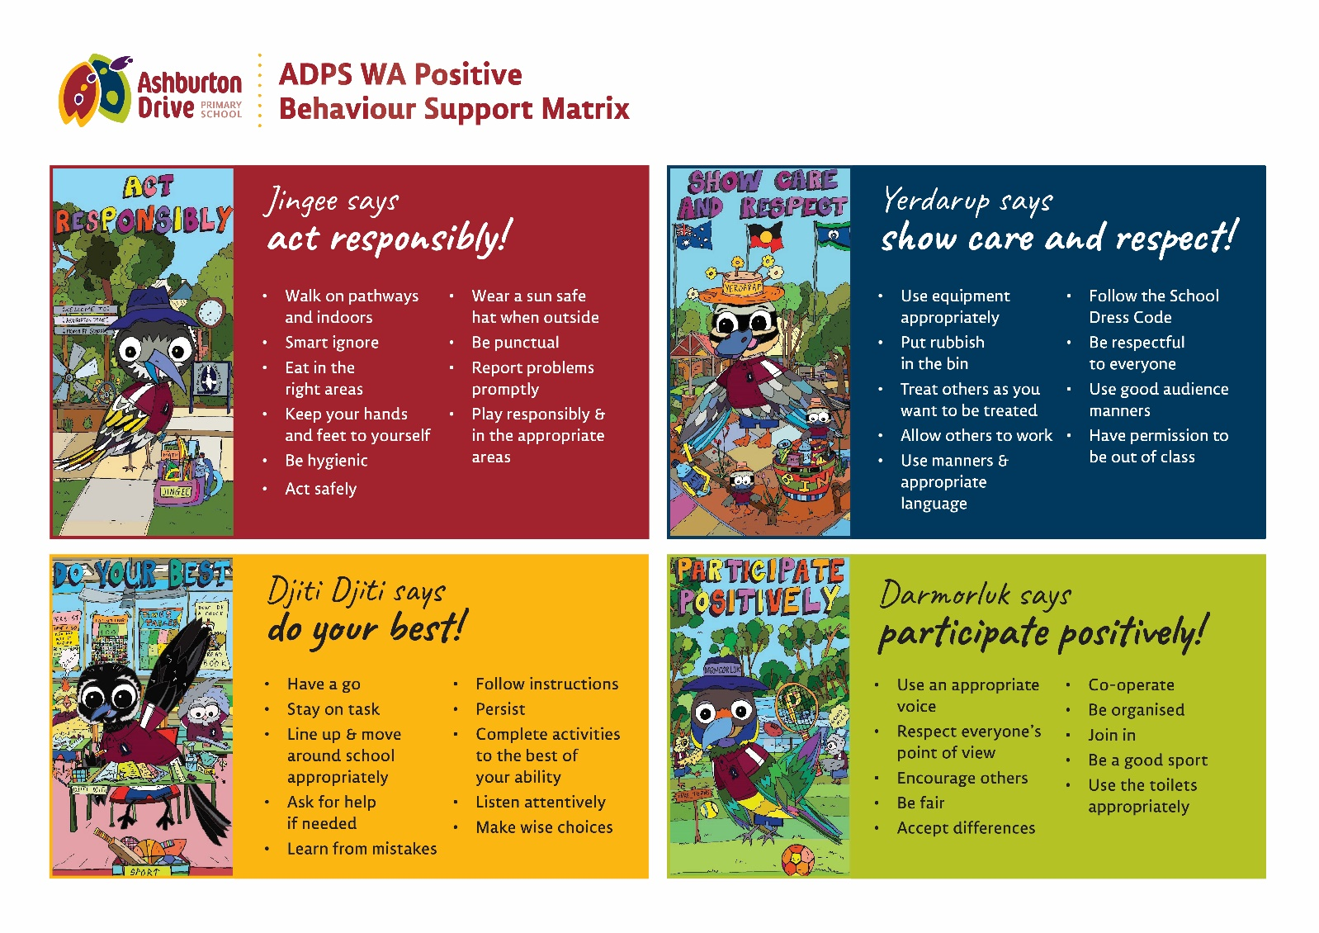

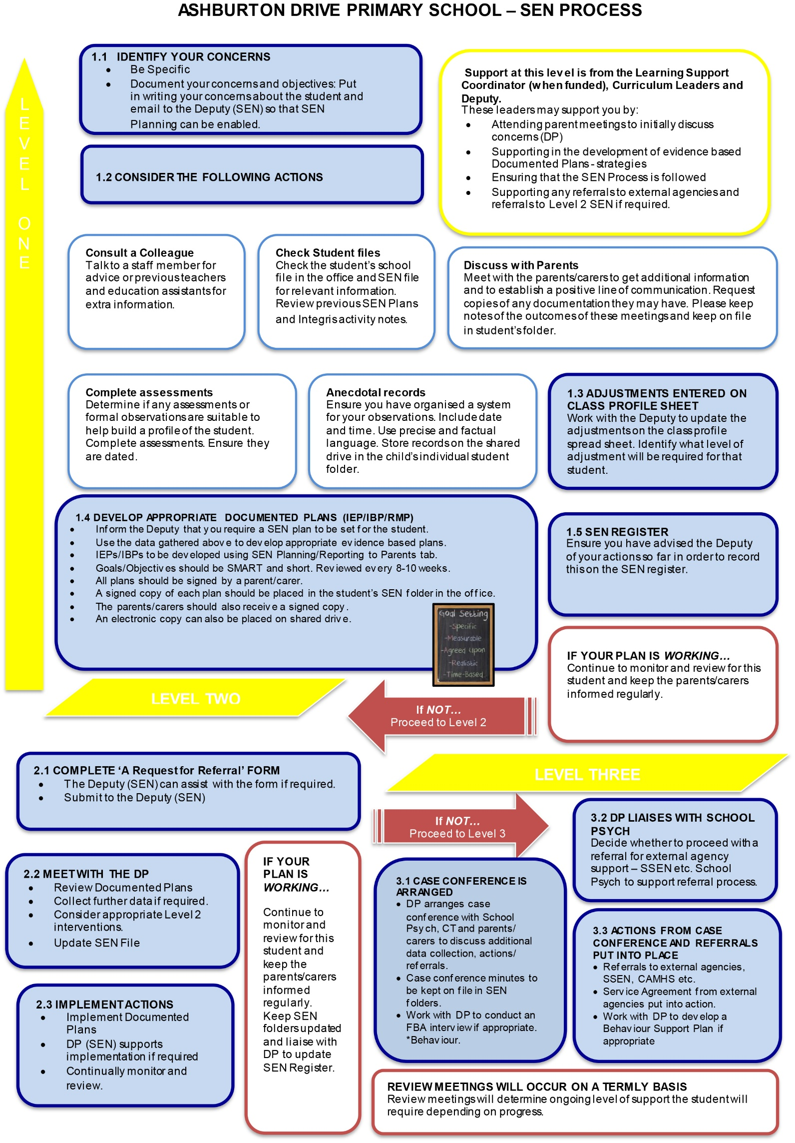
APPENDIX 2 – SEN Process chart
APPENDIX 3 – Ashburtoken System Chart

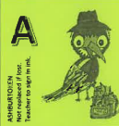
Student achieves 1 GREEN token

3
5
4
1
2

When 5 GREEN tokens have been achieved they are placed in the class pencil case, then they come to the office for an entry in the “Green Token Tree” daily prize draw and are exchanged for
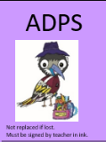
1 PURPLE token

5
3
4
1
2

When 5 PURPLE tokens have been achieved, they are placed in the class pencil case and taken to the office for processing. Plus all students receive a
TRY-ATHLON Certificate at assembly.
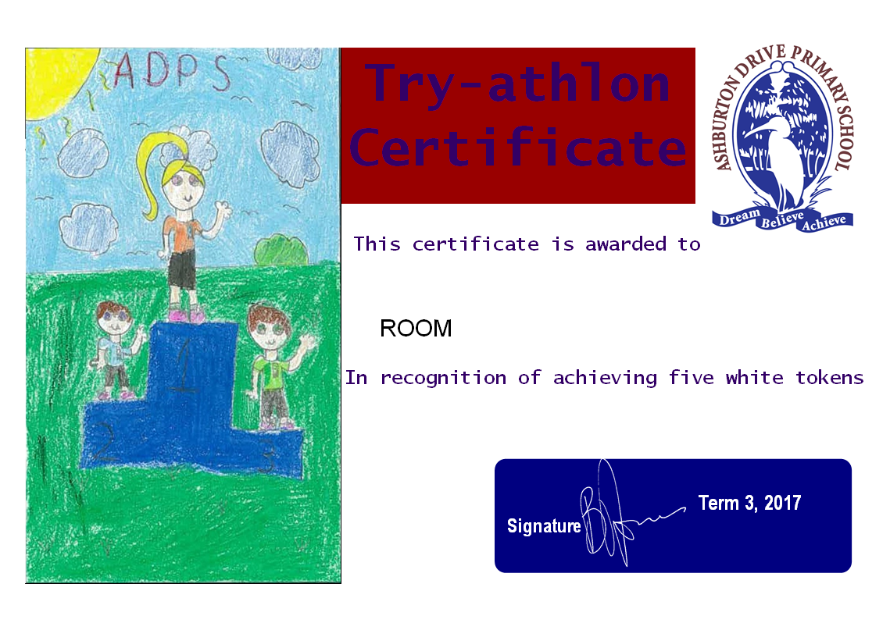

5
1
2
3
4


When 5 TRY-ATHLON certificates have been achieved, students receive a MEDALLION.
5 x TRY-ATHLON certificates = Bronze Medallion
10 x TRY-ATHLON certificates (total) = Silver Medallion
15 x TRY-ATHLON certificates (total) = Gold Medallion
20 x TRY-ATHLON certificates (total) = Platinum Medallion
25 x TRY-ATHLON certificates (total) = Plaque
Try-athalon certificates are recorded at school but sent home.

APPENDIX 4 – Personal Best Information for Parents

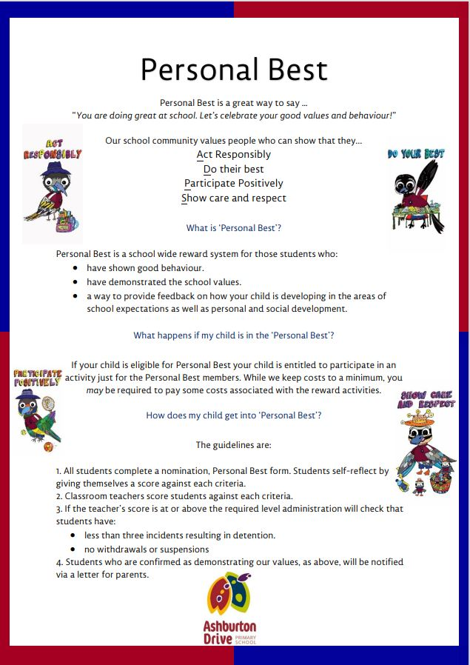

APPENDIX 5 – Anti-Bullying information for parents
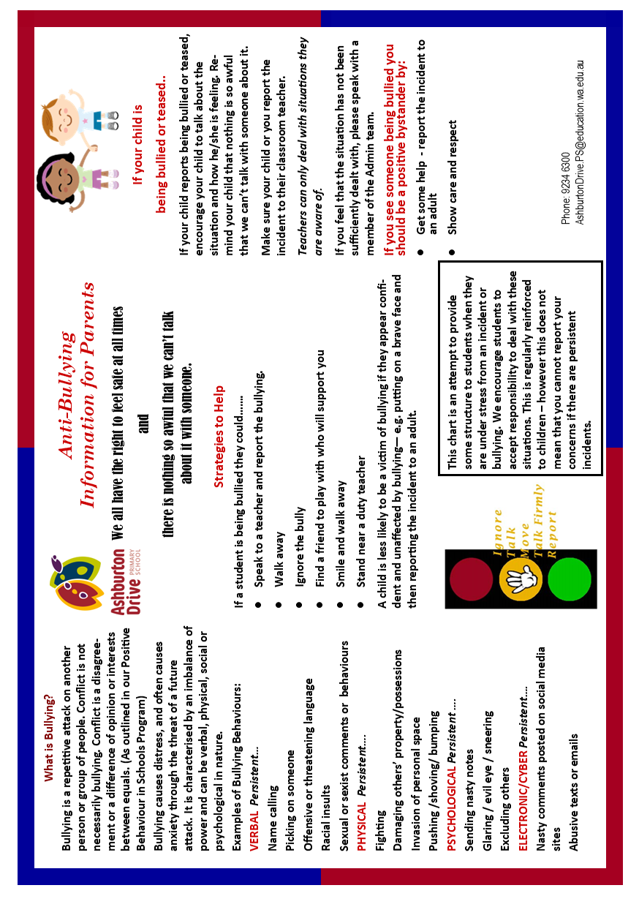

APPENDIX 6 - Rights and responsibilities

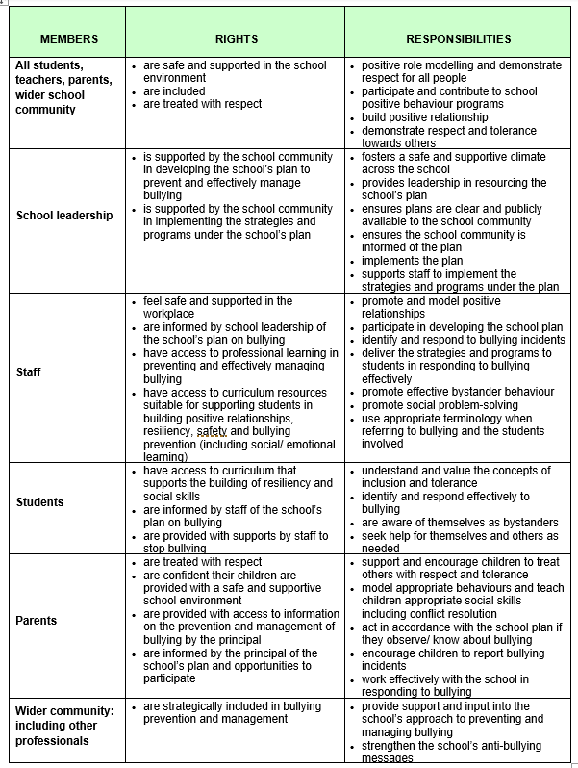

APPENDIX 7 – Connect and Respect resources

